# Gym Management System Application

Create a gym management system including members, fee packages and bills.

# Database design

This app can revolve around this simple design:

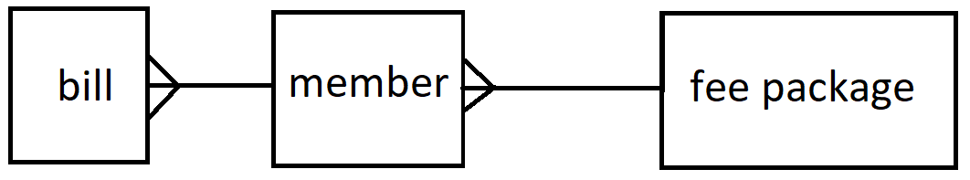

# fee package

This is a type of membership that can be selected by a member. A few of these should be prepopulated. Having a form that creates / edits / deletes fee packages can also be incorporated.

# member

A member is a customer. The app user can create / edit / delete members and associate each member with a fee package using a form.

# bill

A bill is per member, per month unless they have frozen their subscription (optional). Bill records get created every month initially in ‘owed’ status and then they are ‘paid’.

# Implementation

This program is best written with a database as there is strong coupling of information.

If a simpler design is desired, please feel free to adapt.

Any amount of complexity can be built on top of this for example by:

* Extending the database to include more information
* Writing responsive CSS for different devices
* Sending messages to people making them aware of status updates (e.g. new appointment)

# Additional things to think about

Passwords for admins (gym employees)

Sessions (security restrictions)

Error handling

User interface / Experience

Testing

Documentation (User guide / walkthrough && readme)

Responsive CSS

# Technologies needed

Angular

C# (Visual Studio web app project)

SQL

# Extended version:

https://codeshoppy.com/shop/product/gym-management-system/